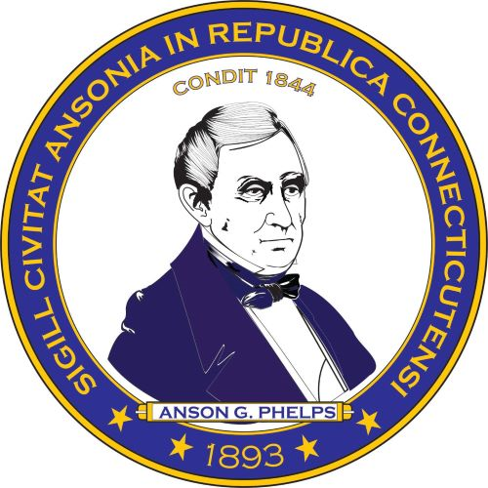

Request for Qualifications for
the sale of its wastewater assets
City of Ansonia

The City of Ansonia is seeking to enter into an agreement with a qualified firm to purchase, upgrade and maintain the City of Ansonia Wastewater Assets. The City reserves the right to choose one or more firms and to reject any and all proposals depending upon the quality of submittals received.
The City is entertaining proposals from firms with complete capabilities meeting the requirements in the specifications. A copy of the requirements needed along with a copy of the current appraisal can be obtained on our website at www.cityofansonia.com or via email to Diana Branch dbranch@ansoniact.org.
There is a mandatory walk through on January 4, 202 at 9am at the Water Pollution Control Facility on North Division Street in Ansonia, CT. The deadline for questions is January 11, 2024 at 4pm.
Deadline for the proposal is 3pm on January 16, 2024. Please submit (4) sealed copies of qualifications to The City of Ansonia, Town and City Clerk, 253 Main Street, Ansonia, CT, 06401.

